Project Design Phase
Problem – Solution Fit Template

Date | 5/July/2026
Team ID
Project Name | Book A Doctor
Maximum Marks | 2 Marks

Problem:
Patients often experience long waiting times, difficulty finding the right doctor, and inconvenience in booking appointments through phone calls or hospital visits. Doctors and hospitals also face challenges such as manual appointment management, scheduling conflicts, and maintaining patient records efficiently.
Solution:
The Book A Doctor web application provides an online platform where patients can register, search for doctors by specialization, view available time slots, and book appointments instantly. Doctors can manage their schedules, view appointments, and update their availability, while the admin manages doctors, patients, and appointment records. This reduces waiting time, prevents double bookings, and improves the overall healthcare experience.
Purpose
To provide a simple and convenient online appointment booking system for patients.
To reduce waiting time and eliminate the need for manual appointment booking.
To help doctors efficiently manage their schedules and appointments.
To improve communication between patients and doctors through a centralized platform.
To reduce paperwork by maintaining digital records of appointments.
To enhance hospital efficiency and increase patient satisfaction.
To provide secure, fast, and user-friendly healthcare services that can be accessed anytime and anywhere.
Template:
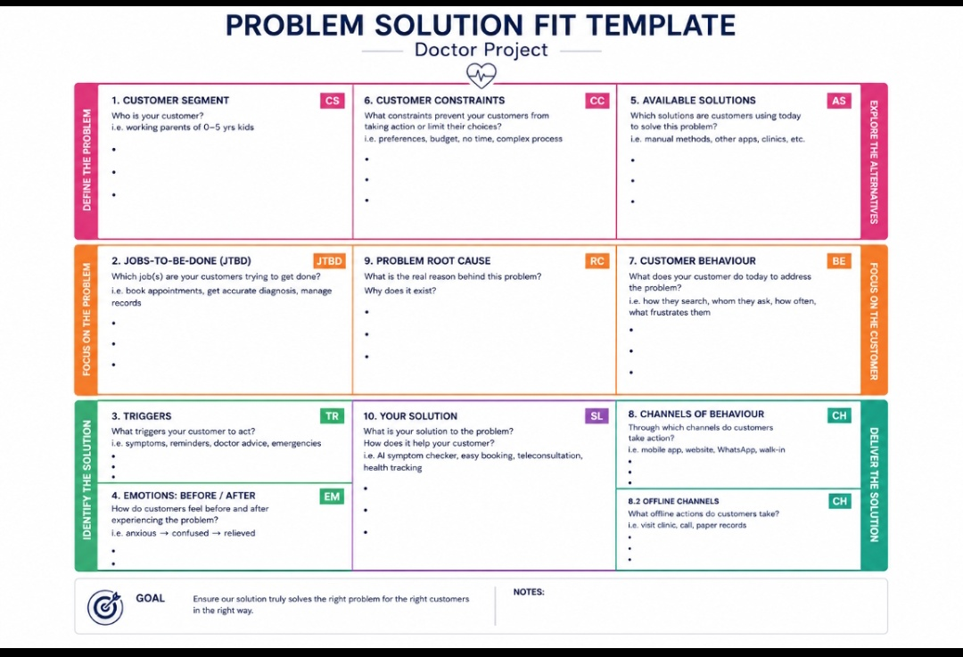

References:
- https://pmc.ncbi.nlm.nih.gov/articles/PMC5425771/⁠� �
- https://pubmed.ncbi.nlm.nih.gov/28446422/⁠� �

